Sample

**Model Interpretation for Chi-Square Tests:**

When examining the association between lifetime major depression (categorical response) and past year nicotine dependence (categorical explanatory), a chi-square test of independence revealed that among daily, young adults smokers (my sample), those with past year nicotine dependence were more likely to have experienced major depression in their lifetime(36.2%) compared to those without past year nicotine dependence (12.7%), X2 =88.60, 1 df, p=0001.

The df or degree of freedom we record is the number of levels of the explanatory variable -1. Here the df is 1 nicotine dependence which has 2 levels (df 2-1=1).

**Model Interpretation for post hoc Chi-Square Test results:**

A Chi Square test of independence revealed that among daily, young adult smokers (my sample), number of cigarettes smoked per day (collapsed into 5 ordered categories) and past year

nicotine dependence (binary categorical variable) were significantly associated, X2 =45.16, 4 df, p=.0001.

Post hoc comparisons of rates of nicotine dependence by pairs of cigarettes per day categories revealed that higher rates of nicotine dependence were seen among those smoking more cigarettes, up to 11 to 15 cigarettes per day. In comparison, prevalence of nicotine dependence was statistically similar among those groups smoking 10 to 15, 16 to 20, and > 20 cigarettes per day.

Chi-Square Independence Test

http://lifeexpectancyproject.tumblr.com/post/151978205370/chi-square-independence-test

Model interpretation of Chi-square tests

A Chi-Square Independence Test was carried between life_exp_cat (category response variable with 5 categories) and income_level_perperson (categorical explanatory variable with 4 categories).

The findings of the test revealed that there is a significant association between income_level_perperson and life_exp_cat

it was observed that as income goes up the there is significant increase in the life expectancy level.

The highest column percentage was between category 4 in income_level_perperson and category 5 in life_exp_cat, which revealed that the persons which have an income above 9425.326(highest category among income_level_perperson) has a life expectancy between 75-85 years (highest category among life_exp_cat).

This finding was further substantiated by the statistics X2=144.44, df=12 and p-value=<.0001

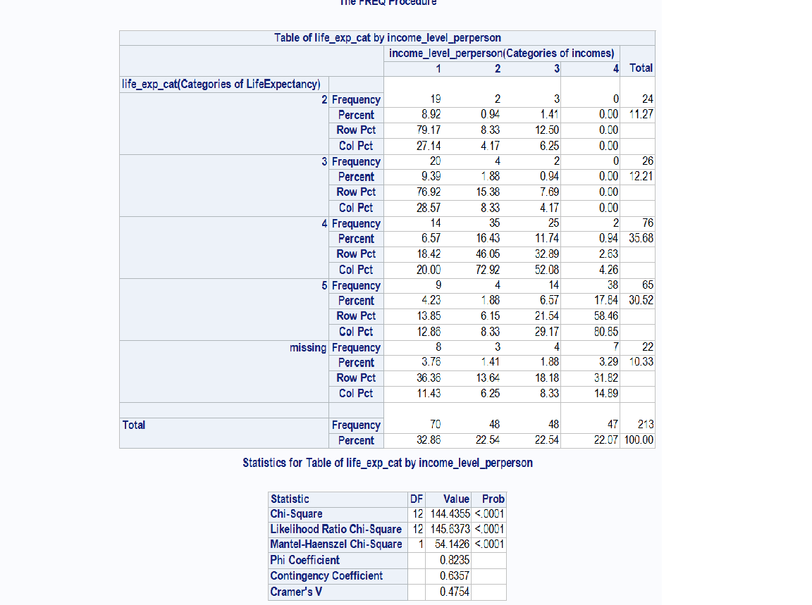

Model Interpretation of Post hoc Chi-square tests

In the Chi-square tests it was revealed that there is significant association between category 4 in income_level_perperson and category 5 in life_exp_cat. This proved that the persons with an income above 9425.326 has a life expectancy between 75-85 years. X2=144.44, df=12 and p-value=<.0001

Post hoc test were conducted since income_level_perperson is a categorical explanatory variable with 4 categories.

In the Post hoc tests it was revealed that category 4 in the categorical explanatory variable income_level_perperson is significantly different than other categories in income_level_perperson, while category 2 in the explanatory variable has significantly different values for the response variable life_exp_cat.